**S3 BUCKET**

**Bucket:**



**Object:**



**Bucket Policy:**

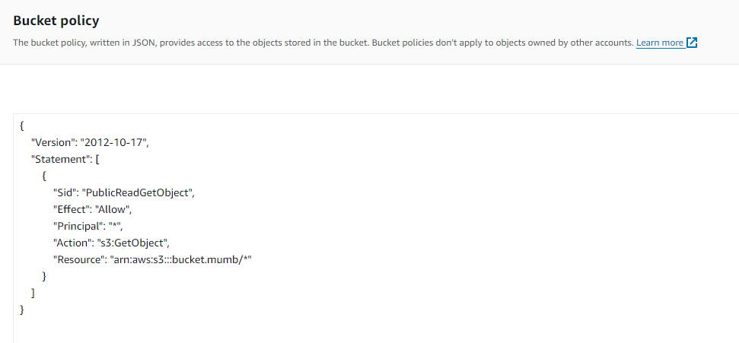

**Static website hosting:**

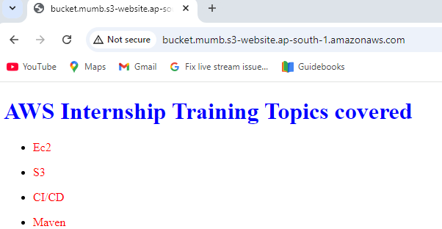

**Bucket Versioning:**

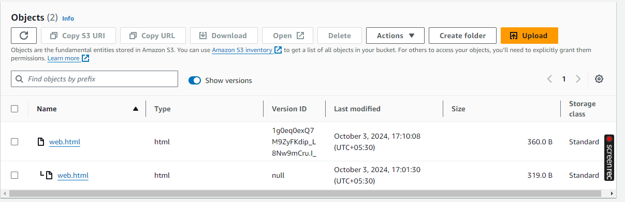

**After Versioning:**

